**Making other debit Card as default**

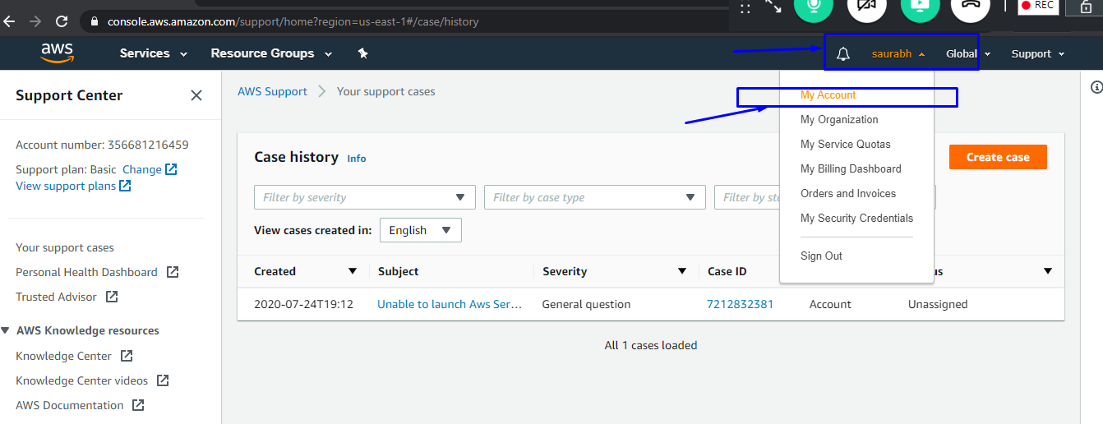

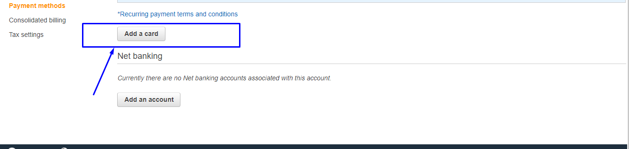

**Once you are done with adding new card you can do the below**

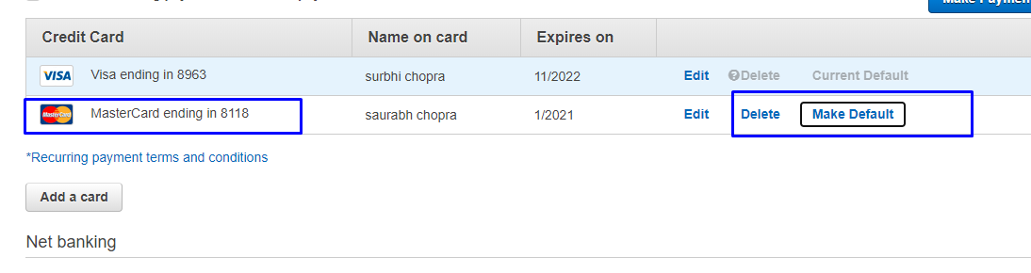

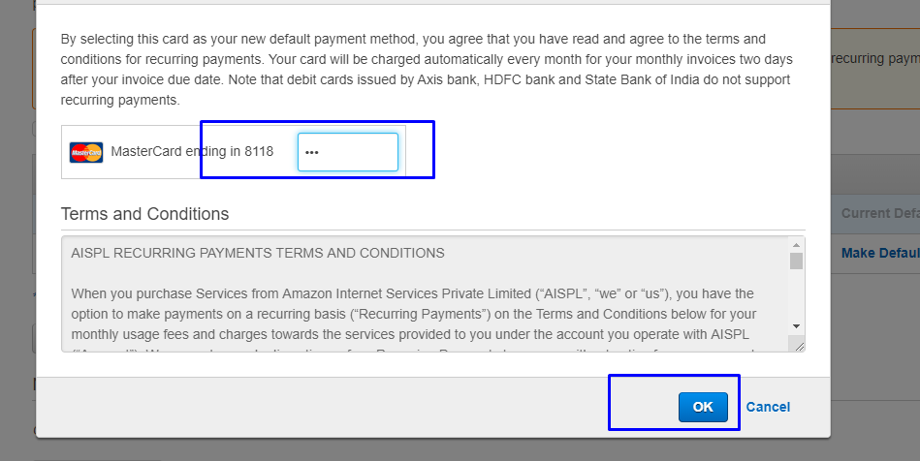

Once you are done with the payment, now you can delete the old card from the account.



Now we have successfully deleted the card details.

